**Motor driver IC to drive the LEGO Motor**

**Datasheet of Driver IC:**

<http://www.semicon.toshiba.co.jp/info/lookup.jsp?lang=en&pid=TB6612FNG>

**Motor Driver board supplier details:**

<http://www.sgbotic.com/index.php?dispatch=products.view&product_id=759>

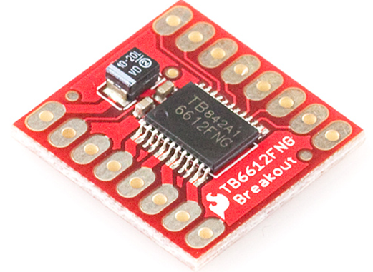

This supplier was used last year.

<http://www.pololu.com/product/713>

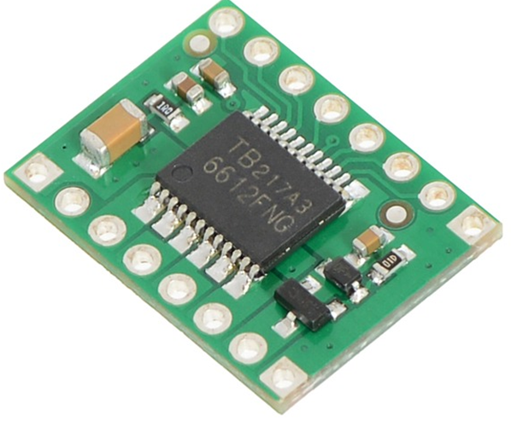

Web Price is lower than the above supplier.

**Interface Details with Controller having PWM & GPIO:**

PWM Output: To drive the LEGO motors [To control speed of 9V Lego Motor].

GPIO Output: To control direction of the motor.

Other requirements such as 9V regulator (7809 IC) and LED indication and series resistors to limit current are required based on the controller used.

**Description:**

The TB6612FNG motor driver can control up to two DC motors at a constant current of 1.2A (3.2A peak). Two input signals (IN1 and IN2) can be used to control the motor in one of four function modes - CW, CCW, short-brake, and stop. The two motor outputs (A and B) can be separately controlled, the speed of each motor is controlled via a PWM input signal with a frequency up to 100kHz. The STBY pin should be pulled high to take the motor out of standby mode.  
  
Logic supply voltage (VCC) can be in the range of 2.7-5.5VDC, while the motor supply (VM) is limited to a maximum voltage of 15VDC. The output current is rated up to 1.2A per channel (or up to 3.2A for a short, single pulse).



**Typical Application Diagram**



**Truth Table**



**Breakout board schematic**